Structural analysis on crank hook
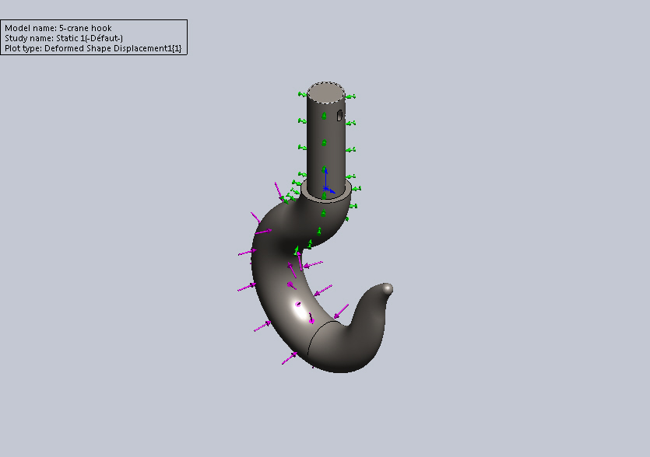
Abstract: To transfer the heavy objects is very difficult. By using crank hook it is easy to carry the heavy loads. Crank hook is a mechanical component used to carry heavy loads and machinery elements to transfer from one place to another place. Heavy crane hooks are used in ship yards. Steel, carbon and high carbon steel are the materials used for manufacturing of crane hooks.
Crank hook undergoes circumferential stress, shear stress.
The main objective of this project is to design a crane hook in SOLID WORKS 2014 and define and analyze different loads on it.

